Assignment 11
Github Account, Exploration A& Professional Profile
Olajide Kuti
https://github.com/Kutiolajide07
Task 1
Screenshot 1 & 2
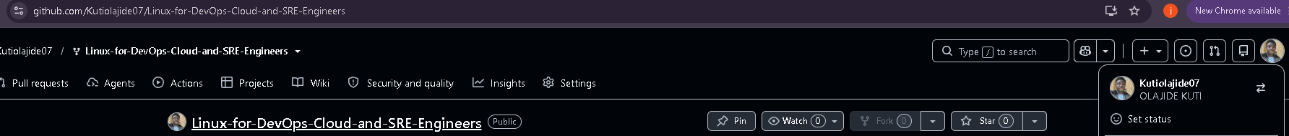
Task 2
Screenshot 3
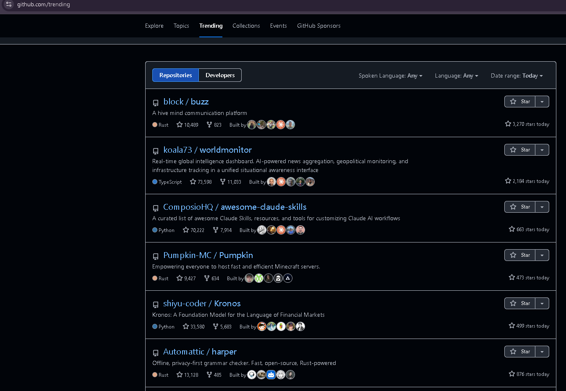
Screenshot 4
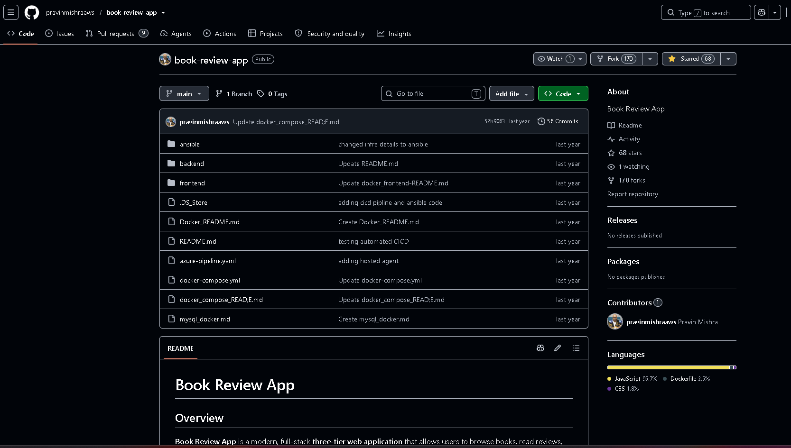
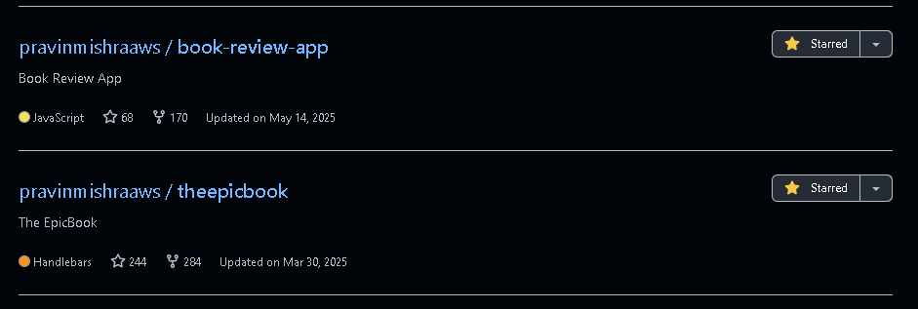
Screenshot 5
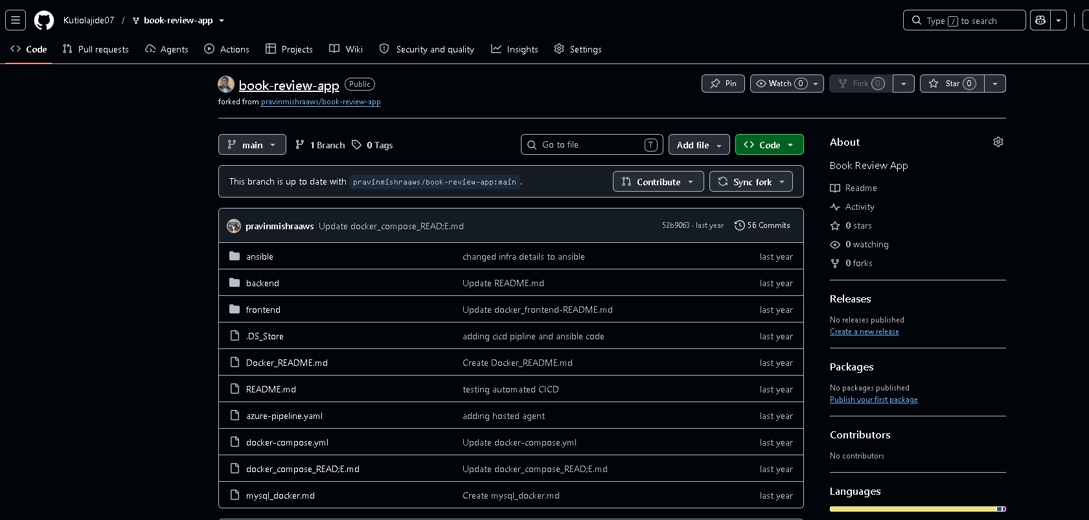
Screenshot 6
